# Target Metrics

Overall - Accuracy: 0.3400, Precision: 0.8365, Recall: 0.3400, F1: 0.4465

Class-specific metrics:

Carbon neutral(ity) - Precision: 0.8462, Recall: 0.4400, F1: 0.5789

Emissions reduction target - Precision: 0.7500, Recall: 0.1200, F1: 0.2069

N/A - Precision: 0.0000, Recall: 0.0000, F1: 0.0000

Net zero - Precision: 0.7500, Recall: 0.6000, F1: 0.6667

No target - Precision: 1.0000, Recall: 0.2000, F1: 0.3333

# Year Metrics

Overall - Accuracy: 0.5900, Precision: 0.5742, Recall: 0.5900, F1: 0.5797

Class-specific metrics:

- Precision: 0.0000, Recall: 0.0000, F1: 0.0000

2020 - Precision: 0.0000, Recall: 0.0000, F1: 0.0000

2021 - Precision: 0.0000, Recall: 0.0000, F1: 0.0000

2022 - Precision: 0.0000, Recall: 0.0000, F1: 0.0000

2023 - Precision: 0.0000, Recall: 0.0000, F1: 0.0000

2025 - Precision: 0.5000, Recall: 0.6000, F1: 0.5455

2030 - Precision: 0.7500, Recall: 0.8400, F1: 0.7925

2031 - Precision: 0.0000, Recall: 0.0000, F1: 0.0000

2031-32 - Precision: 0.0000, Recall: 0.0000, F1: 0.0000

2032 - Precision: 0.0000, Recall: 0.0000, F1: 0.0000

2033 - Precision: 0.0000, Recall: 0.0000, F1: 0.0000

2035 - Precision: 0.8333, Recall: 1.0000, F1: 0.9091

2040 - Precision: 1.0000, Recall: 0.8000, F1: 0.8889

2050 - Precision: 0.8148, Recall: 0.8148, F1: 0.8148

2060 - Precision: 0.0000, Recall: 0.0000, F1: 0.0000

No target - Precision: 0.0000, Recall: 0.0000, F1: 0.0000

None - Precision: 0.0000, Recall: 0.0000, F1: 0.0000

designated year - Precision: 0.0000, Recall: 0.0000, F1: 0.0000

# Other Metrics

Quote Accuracy: 0.3700

Overall Accuracy: 0.2600

Valid XML Percentage: 1.0000

# Confusion Matrices

Target Confusion Matrix:

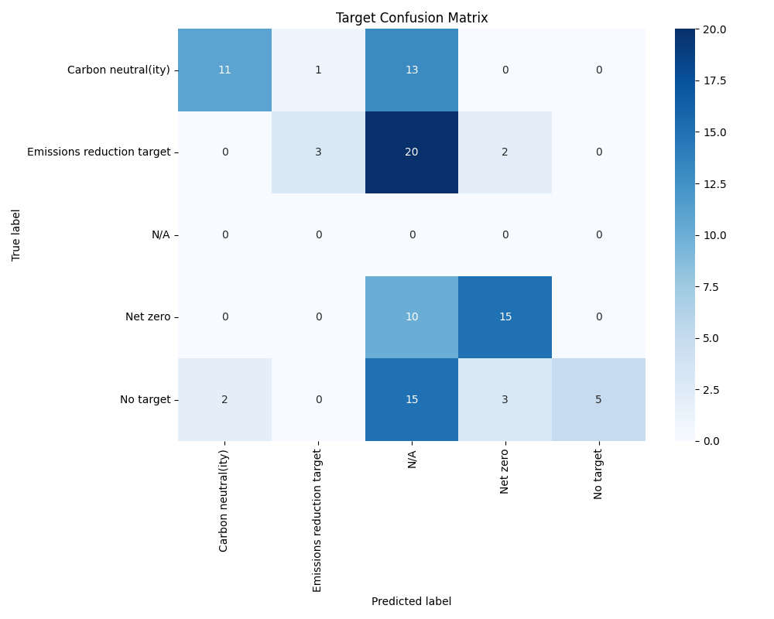

Year Confusion Matrix:

